Name | Ndongla Roy Longpi
Department | Computer Networking and Security
Task | Stored XSS vulnerability

STORED XSS SESSION HIJACKING SIMULATION
Stored XSS: refers to a type of cross site scripting where the malicious script gets saved on the server in a database and then served back to every user who views the affected page without needing them to click a special link.
Session hijacking: this occurs when an attacker takes over a legitimates users authenticated session without knowing their username or password by stealing ot guessing the token that the server uses to recognize the browser is logged in as user.
In order to carry out stored out scripting, I used Kali Linux, a python extension and a vulnerable app or web page which in this case I will be using DVWA.
I will be carrying out, stored XSS and session hijacking in the following steps bellow.

- Setting up my XSS lab.
Setting up my XSS lab involves running commands on kali Linux for starting up Apache, MariaDB and giving me a link for accessing my DVWA through a local browser.
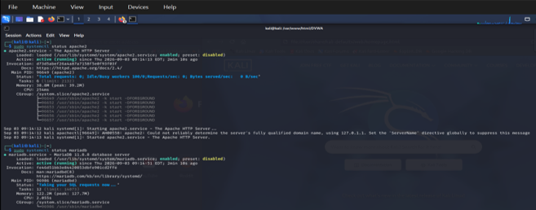

- Setting up the listener for catching the exfiltrated cookie.
Secondly, I created my listener. In order to create a listener I needed a python extension which was accessible through Linux by entering the command “nano listerner.py” were I entered my code.

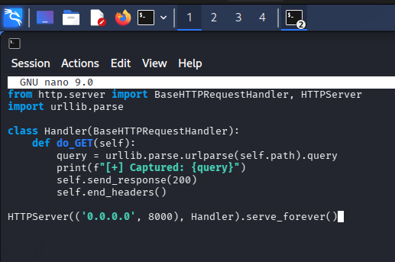
- Getting my kali ip.
After successfully generating my listener, i ran a command on kali Linux to obtain the ip address of my active interface is to be used on the payload.

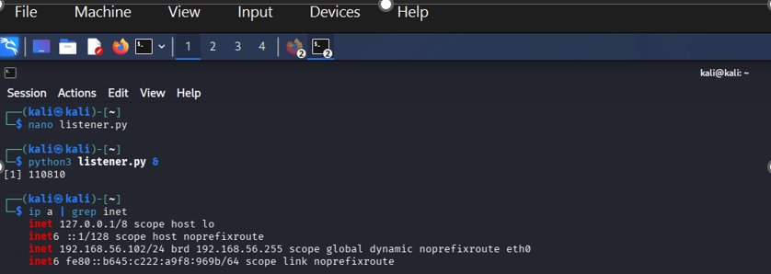
- Start the listener.
The next thing I did, was to run my listener on kali Linux, in order for it to capture any session cookie.

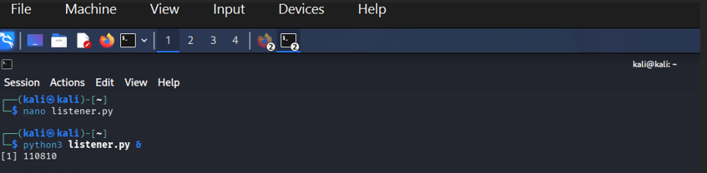

- Log into DVWA and setting security level.
I then accessed my vulnerable webpage via a website using it URL and I log in using default credentials.

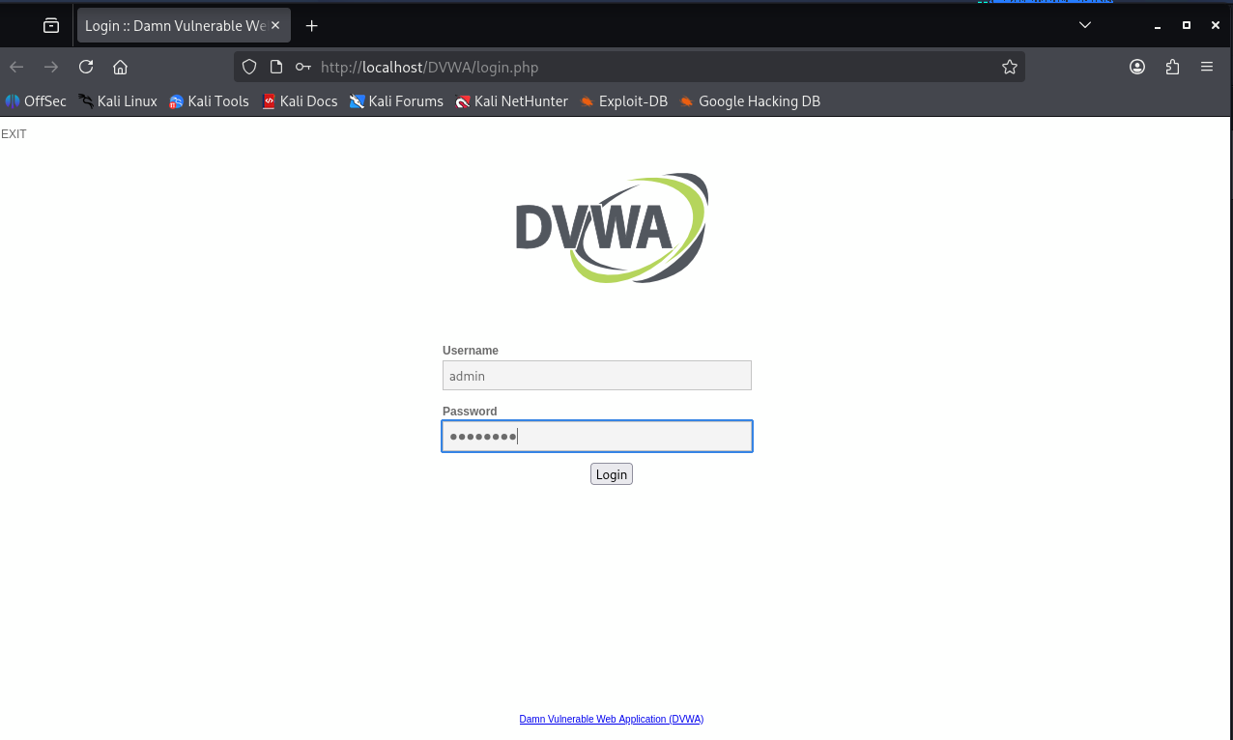

After log into the web page, I navigated to the DVWA were I changed the security level from impossible to low and submit. Once the security level was low, I was capable of performing any task I wanted.
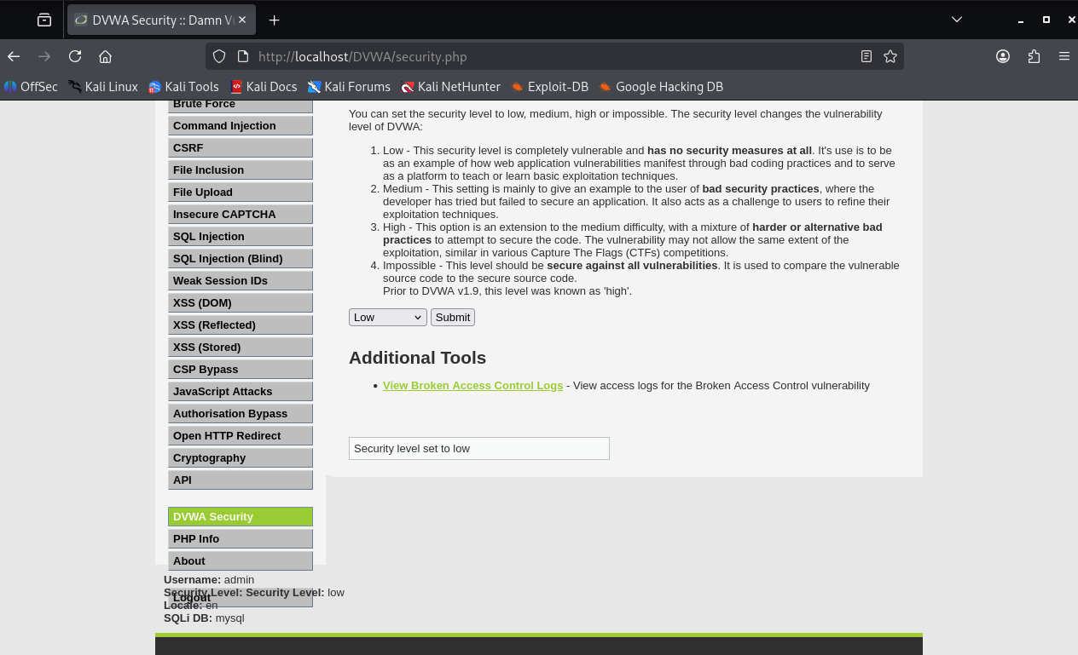

- Injecting payload.
Once the security level was low, I when to the XSS stored module. Under the XSS module I gave the name a default name “text” and under message I injected my payload and clicked on sign guestbook.
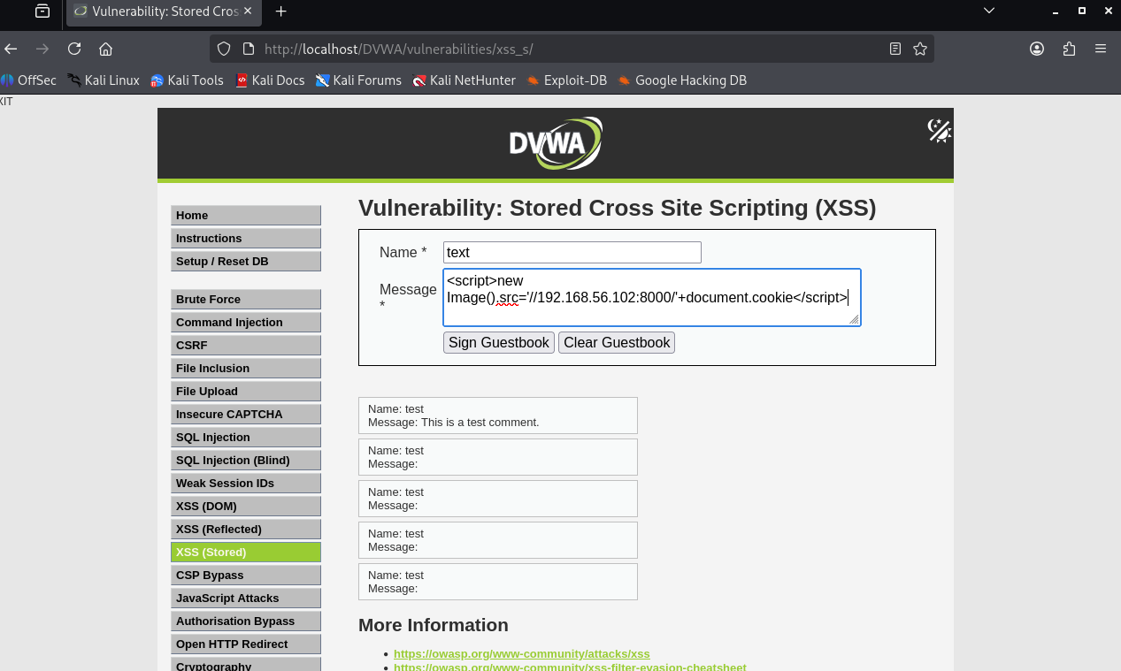
This are the various payload I entered although message is empty.
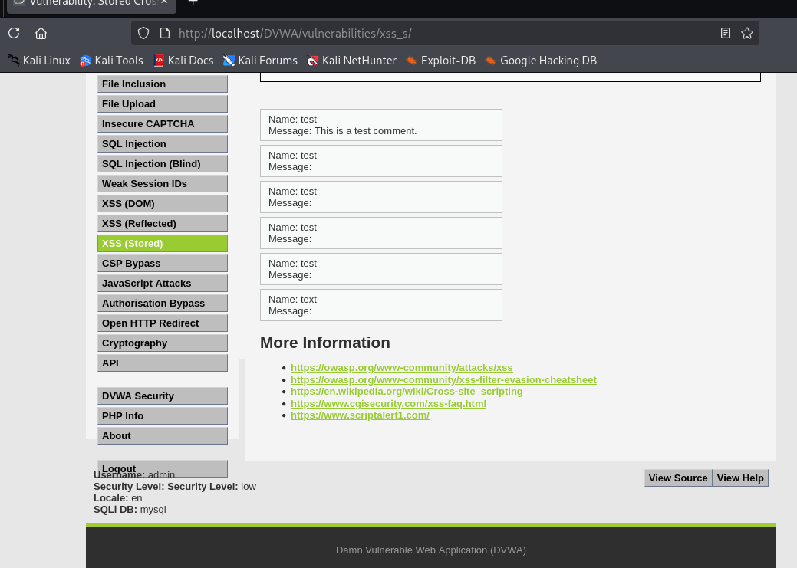

- Captured session cookie
After running my payload, I when back to my kali terminal and check the capture session by my running terminal.

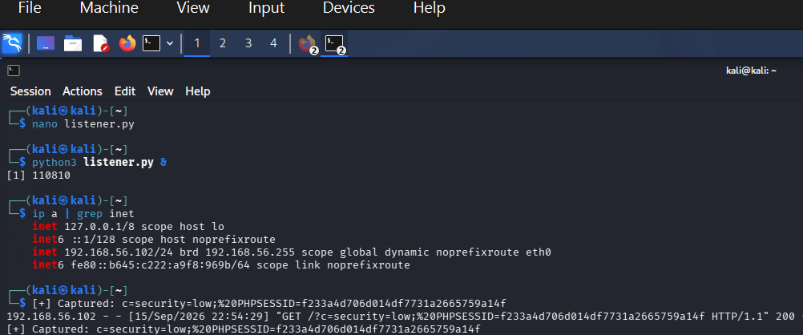

- proof of session cookie.
In order to show that session cookie exfiltration has occurred, I when to stored XSS inspector; under storage were I found the security cookie value and the PHPSESSID which is going to be use to perform hijacking.

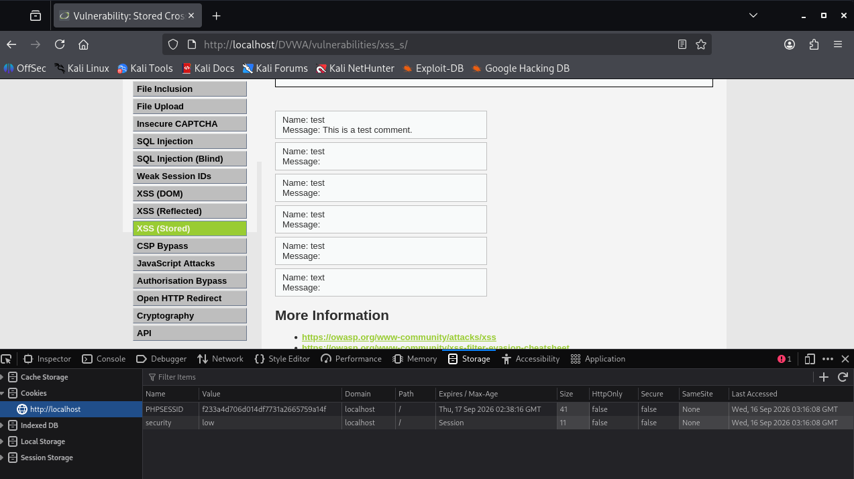
- performing hijacking.
in order to perform hijacking, I first opened a private Firefox window through which I opened my vulnerable webpage.
After opening the webpage, I navigated to the stored XSS module, where I when to its storage tab cookies and replaced the PHPSESSID together with the value with the captured session from the listener.
before replacement with captured cookie sessions.
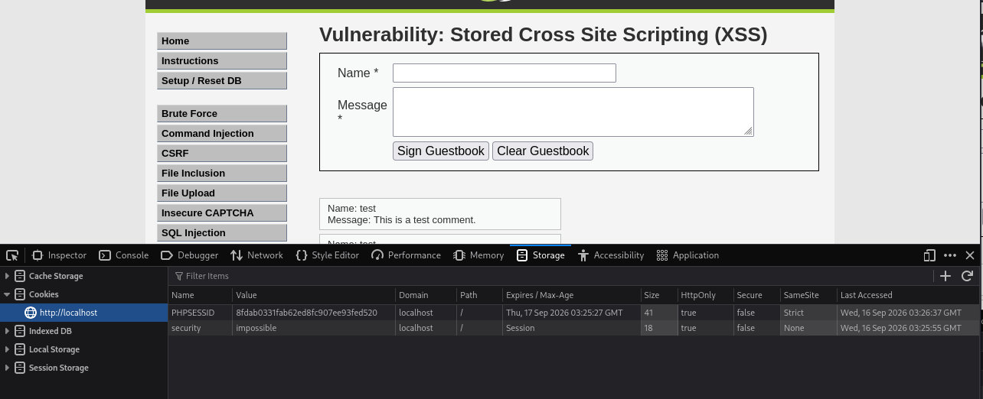
After replacement with captured cookie session.
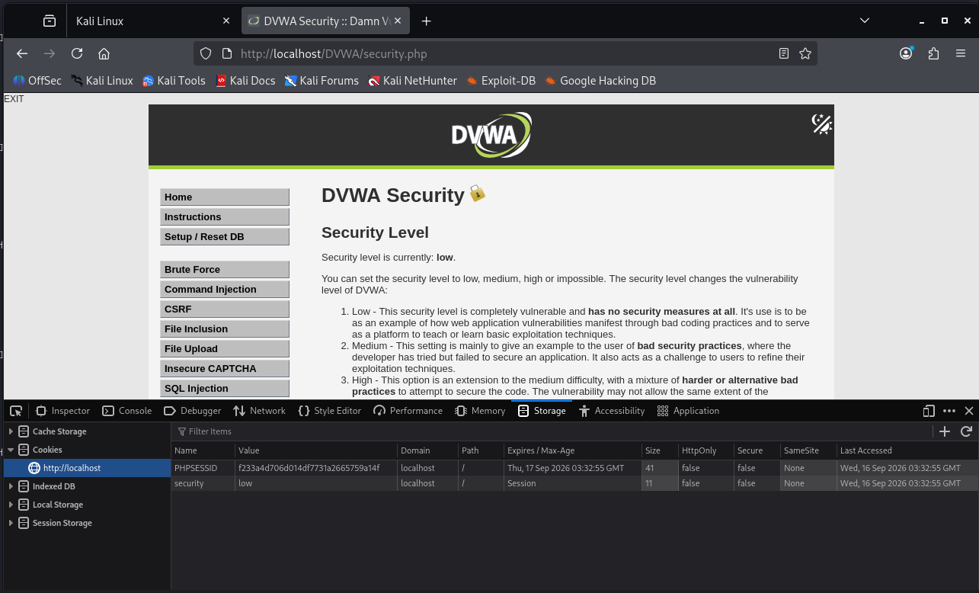

Lastly after I refreshed the page, I wasn’t log out, indicating I was known logged in as an authenticated admin in the browser context who has no valid credentials. Hence session hijacking is complete and successfully.

